INTERFACE CONTROL DOCUMENT
VERSION 1.0.0

Beauty and Health Service (BHS)

Version# | Implemented By | Date | Description
1.0.0 | - | 26/04/2023 | Version 1.0.0: API Method names as follows  - “package_list”  - “gen_health_voucher”.  - “confirm_voucher”  - “callback_result”

Introduction
- SECRET_KEY *must be requested from the service provider
- PUBLIC_KEY *must be requested from the service provider
To encode the X-API-KEY you will use SECRET KEY with the timestamp as follows:
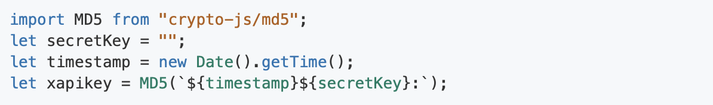
When you get the X-API-KEY, you can set the value in the header.
- X-API-KEY :
- timestamp
- key : Is PUBLIC_KEY must be requested from the service provider
The example code is :
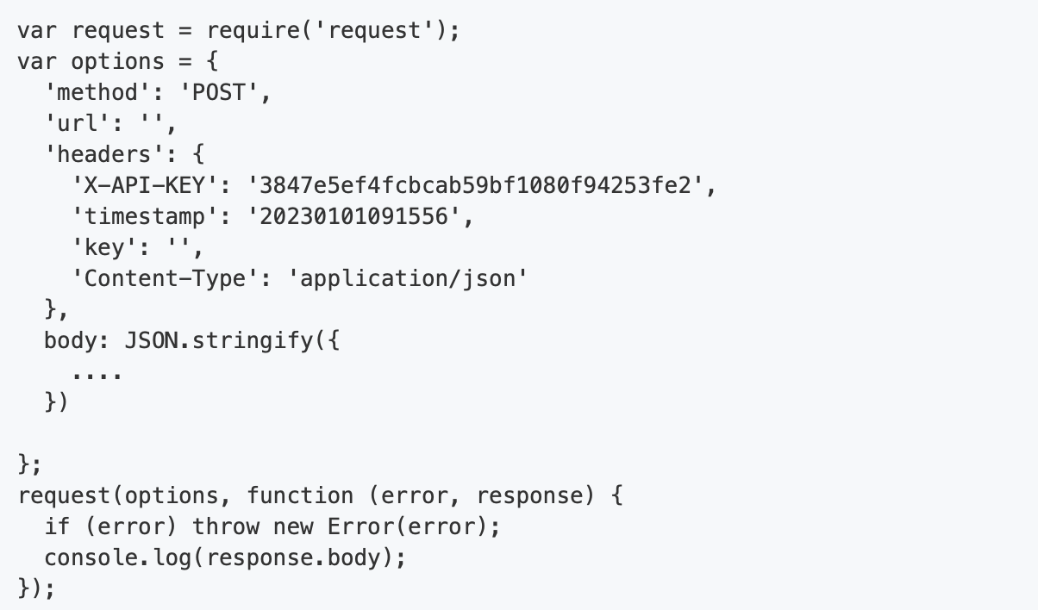

APIs to call from WeGoThailand to BHS Backend
Input:
1. Service Packages List - GET

No. | Field Name | Field Type | Field Size | Required | Field Description | Sample Data
1. | X-API-KEY | String |  | Yes | To encode the X-API-KEY you will use SECRET KEY with the timestamp | Header key X-API_KEY = 3847e5ef4fcbcab59bf1080  f94253fe2
2. | timestamp | String |  | Yes | The current time of an event that a computer records | Header key timestamp= 20230101091556
3. | key | String |  | Yes | Is PUBLIC_KEY must be requested from the service provider | Header key key=
4. | category | String |  | Yes | Filter category of package. | HEALTH
5. | Lang | String |  | Yes | Languages | EN

Output:
1. Service Packages List

No. | Field Name | Field Size | Field Type | Required | Field Description | Sample
1. | success |  | String | Yes | Response status
2. | Message |  | String | Yes | Response message
3. | result |  | Array of Object | Yes
3.1 | package_code |  | String | Yes
3.2 | package_category |  | String | Yes |  | HEALTH
3.3 | package_name |  | String | Yes
3.4 | package_detail |  | String | Yes |  | Beauty and Health
3.5 | package_price_thb |  | String | Yes |  | 13800.00
3.6 | package_price_usd |  | String | Yes |  | 400.00
3.7 | package_price_cny |  | String | Yes |  | 2780.00
3.8 | terms_of_use |  | String | Yes
3.9 | package_image |  | String | Yes |  | https://xxxx.com/xxxx.jpeg
3.10 | ref_link |  | String | Yes |  | https://xxxx.com/xxxx.pdf

Input:
- Generate BHS Voucher – POST

No. | Field Name | Field Type | Field Size | Required | Field Description | Sample Data
1. | X-API-KEY | String |  | Yes | To encode the X-API-KEY you will use SECRET KEY with the timestamp | Header key X-API_KEY = 3847e5ef4fcbcab59bf1080  f94253fe2
2. | timestamp | String |  | Yes | The current time of an event that a computer records | Header key timestamp= 20230101091556
3. | key | String |  | Yes | Is PUBLIC_KEY must be requested from the service provider | Header key key=
4. | PaymentReceiptRefNumber | String |  | Yes | Unique identifier for the individual applications payment
5. | WebReferenceNumber | String |  | Yes | Unique identifier provided by VFS for every application
6. | ApplicantName | String |  | Yes | Applicant full name
7. | Email | String |  | Yes | Email
8. | Mobile | String |  | Yes | Mobile Number
9. | NationalityId | Int32 |  | Yes | Id of nationality master
10. | GivenName | String |  | Yes | First name
11. | SurName | String |  | Yes | Last name
12. | MiddleName | String |  | No | Middle name
13. | PassportNumber | String |  | Yes | Passport Number
14. | PassportExpiryDate | String |  | Yes | Passport expiry date. Format: YYYY-MM-DD
15. | PassportIssueDate | String |  | Yes | Passport issue date. Format: YYYY-MM-DD
16. | DateOfBirth | String |  | Yes | Date of birth. Format: YYYY-MM-DD
17. | ResidencyId | Int32 |  | Yes | Id of residence master
18. | GenderId | Int32 |  | Yes | Id of gender master
19. | SalutationId | Int32 |  | Yes | Id of Salutation master
20. | PassportTypeId | Int32 |  | Yes | Id of Passport type master
21. | PermanentAddress | String |  | Yes | Permanent Address
22. | State | String |  | Yes | State
23. | PlaceOfIssue | String |  | Yes | Place of passport issue
24. | OccupationId | Int32 |  | Yes | Id of occupation master
25. | ArrivalAirportId | Int32 |  | Yes | Id of Arrival Airport master
26. | ArrivalDate | String |  | Yes | Date of arrival. Format: YYYY-MM-DD
27. | ArrivalTime | String |  | Yes | Time of arrival. Format: HH:MM
28. | ArrivalFlightNumber | String |  | Yes | Arrival flight number
29. | ArrivalAirlinesId | Int32 |  | Yes | Id of Arrival Airlines master
30. | DepartureDate | String |  | Yes | Date of departure. Format: YYYY-MM-DD
31. | DepartureTime | String |  | Yes | Time of departure. Format: HH:MM
32. | DepartureFlightNumber | String |  | Yes | Departure flight number
33. | DepartureAirlinesId | Int32 |  | Yes | Id of Departure Airlines master
34. | packageCode | String |  | No | packageCode from PackageList

Output:
2. Generate BHS Voucher

No. | Field Name | Field Size | Field Type | Required | Field Description | Sample
1. | success |  | String | Yes | Response status
2. | Message |  | String | Yes | Response message
3. | result |  | Object | Yes
3.1 | paymentReceiptRefNumber |  | String | Yes |  | 2021070900010-G25352342
3.2 | webReferenceNumber |  | String | Yes |  | W022757997210292021070900010-G25352342
3.3 | voucherCode |  | String | Yes |  | b177b13bcee4d18a3e52eaf518401964
3.4 | voucherUrl |  | String | Yes |  | https://xxxx.com/xxxx.pdf

APIs to call from BHS Backend to WeGoThailand
Input:
- Confirm Voucher – POST

No. | Field Name | Field Type | Field Size | Required | Field Description | Sample Data
1. | X-API-KEY | String |  | Yes | To encode the X-API-KEY you will use SECRET KEY with the timestamp | Header key X-API_KEY = 3847e5ef4fcbcab59bf1080  f94253fe2
2. | timestamp | String |  | Yes | The current time of an event that a computer records | Header key timestamp= 20230101091556
3. | key | String |  | Yes | Is PUBLIC_KEY must be requested from the service provider | Header key key=
4. | VoucherCode | String |  | Yes | Unique identifier for the voucher
5. | PassportNumber | String |  | Yes | Passport Number
6. | HospitalNumber | String |  | Yes | HN: Hospital Number
7. | HospitalCode | String |  | Yes | Hospital Code. According to MOPH
8. | HospitalName | String |  | Yes | Hospital Name
9. | TestedDate | String |  | Yes | Date of testing RT-PCR. Format: YYYY-MM-DD
10. | TestedTime | String |  | Yes | Time of testing RT-PCR. Format: HH:MM
11. | Remark | String |  | No

Output:
3. Confirm Voucher
No. | Field Name | Field Size | Field Type | Required | Field Description | Sample
1. | success |  | String | Yes | Response status
2. | Message |  | String | Yes | Response message

Input:
4. Callback the Result – POST

No. | Field Name | Field Type | Field Size | Required | Field Description | Sample Data
1. | X-API-KEY | String |  | Yes | To encode the X-API-KEY you will use SECRET KEY with the timestamp | Header key X-API_KEY = 3847e5ef4fcbcab59bf1080  f94253fe2
2. | timestamp | String |  | Yes | The current time of an event that a computer records | Header key timestamp= 20230101091556
3. | key | String |  | Yes | Is PUBLIC_KEY must be requested from the service provider | Header key key=
4. | VoucherCode | String |  | Yes | Unique identifier for the voucher
5. | PassportNumber | String |  | Yes | Passport Number
6. | HospitalNumber | String |  | Yes | HN: Hospital Number
7. | HospitalCode | String |  | Yes | Hospital Code. According to MOPH
8. | HospitalName | String |  | No | Hospital Name
9. | ReportDateTime | String |  | Yes | Format: YYYY-MM-DDTHH:MM:SS.ssss
10. | VaccinatedStatus | Boolean |  | Yes | History of vaccination. Y: Have been vaccinated, N: Never
11. | SpecimenDate | String |  | Yes | Date of collection specimen. Format: YYYY-MM-DD
12. | LabHisRefCode | String |  | Yes | Reference number of HIS
13. | LabHisRefName | String |  | Yes | Lab name of HIS. Ex. "SARS : coronavirus 2, qualitative RT-PCR"
14. | LabReportDate | String |  | Yes | Report Date from LAB. Format: YYYY-MM-DD
15. | LabReportResult | String |  | Yes | Positive or Negative
16. | LabReportResultUrl | String |  | Yes | Report URL.

Output:
4. Callback the Result

No. | Field Name | Field Size | Field Type | Required | Field Description | Sample
1. | success |  | String | Yes | Response status
2. | message |  | String | Yes | Response message

